ASSIGNMENT REPORT
Submitted in partial fulfilment for the course of
CSA1104 — OBJECT ORIENTED ANALYSIS AND DESIGN
towards the award of the degree of
BACHELOR OF ENGINEERING
IN COMPUTER SCIENCE AND ENGINEERING
Submitted by Niranjana A (192521370)
Under the Supervision of
Dr. A. Gayathri
SIMATS ENGINEERING

Saveetha Institute of Medical and Technical Sciences
Chennai – 602105
September 2026

Table of Contents
1. Executive Summary
2. Problem Analysis and Requirement Summary
3. Object-Oriented Development Approach (CO1)
4. Functional Requirements
5. Non-Functional Requirements
6. Actor and External System Identification
7. Use Case Descriptions
8. Use Case Diagram
9. Object and Class Identification (CO3)
10. Class Diagram
11. Sequence / Interaction Diagrams
12. Activity Diagram
13. State Transition Diagram
14. Package Diagram
15. Component Diagram
16. Deployment Diagram
17. Object Responsibility Analysis
18. Design Axioms, Principles and Patterns
19. Assumptions, Constraints, Security and Privacy
20. Requirement-to-Use Case/Class Traceability Matrix
21. Implementation / Prototype and Results
22. Consistency and Design Evaluation
23. SDG Relevance and Course Outcome Mapping
24. Reflection on Design Decisions
25. Conclusion
26. GitHub Repository Plan
27. References
1. Executive Summary
This report presents an Object-Oriented Analysis and Design (OOAD) study for the AI-Enabled Disaster Resilience and Emergency Response Platform (AIDERP), a system intended to help communities, emergency coordinators, hospitals, shelters, volunteers and utility crews prepare for, respond to and recover from disasters such as floods, cyclones, fires, earthquakes and heatwaves.
The platform draws information from four broad channels: citizen-submitted incident reports, a network of IoT field sensors, third-party weather and mapping feeds, and status updates from hospitals, shelters and utility teams. A dedicated assessment module converts this raw information into a ranked, explainable threat score that supports — rather than replaces — the judgement of a human emergency coordinator.
The design deliberately separates four concerns that are easy to blur in a rushed implementation: (a) collecting information from the public versus verifying it, (b) generating an automated risk estimate versus deciding whether to act on it, (c) coordinating field response versus managing shared resources, and (d) day-to-day operational data versus the audit trail required for accountability. Keeping these concerns in separate classes and services is the central design decision that shapes every UML view in this report.
The remainder of the document develops the requirement analysis, actor and object identification, eight UML perspectives (use case, class, sequence, activity, state, package, component and deployment), a responsibility analysis grounded in GRASP, applicable design patterns, a security and privacy review, a traceability matrix, a prototype outline and a closing reflection connected to the Sustainable Development Goals.

2. Problem Analysis and Requirement Summary

2.1 Nature of the Problem Domain
Emergency response is inherently a race between the arrival of information and the arrival of harm. Three properties of the domain drive the architecture chosen in this report:
- Heterogeneous, contradictory inputs — a citizen photo, a sensor spike and a weather warning may disagree about the same event and must be reconciled rather than blindly merged.
- Time pressure with incomplete data — decisions cannot wait for perfect information, so the system must support staged confidence (unverified → validated) instead of an all-or-nothing gate.
- High consequence of automation error — an unattended AI decision to dispatch, evacuate or stand down carries real-world risk, so every irreversible action requires an accountable human or a clearly bounded automatic rule.

2.2 Domain-to-Design Mapping
Domain Concern | Design Response
Public reporting of incidents | IncidentReport entity with a lifecycle status separate from validation status
Field sensor telemetry | SensorDevice / SensorReading pair with independent validation rules
Automated threat scoring | ThreatAssessment produced by a pluggable ScoringStrategy, stored as a value alongside — not inside — the incident
Team and equipment coordination | TaskAssignment mediates between ResponseTeam and Equipment so neither is modified directly by the other
Facility capacity | ReliefCenter abstraction shared by MedicalCenter and SafeShelter
External service volatility | All third-party integrations (mapping, weather, messaging) sit behind adapter interfaces
Accountability | ActivityLog records every state-changing action against an authenticated identity

2.3 System Boundary
The AIDERP boundary covers incident intake, validation, threat assessment, team dispatch, alert broadcast, route and shelter guidance, relief-center capacity tracking, equipment/resource management, activity logging and account administration. Weather services, mapping/geocoding providers, SMS/push gateways, the IoT sensor network and external emergency-service systems (police, fire, ambulance dispatch) are treated as outside collaborators reached only through adapter interfaces.

3. Object-Oriented Development Approach (CO1)

3.1 Object Basics Applied to AIDERP
An object in AIDERP bundles state with the operations that are allowed to change that state. For example, an IncidentReport object holds attributes such as reportId, category and status, and exposes operations such as validate(), escalate() and close() rather than allowing any caller to overwrite status directly.
- Encapsulation — status fields on IncidentReport, TaskAssignment and ReliefCenter change only through guarded methods that enforce legal transitions.
- Abstraction — MappingProvider, WeatherProvider and MessagingProvider hide vendor-specific detail behind a small, stable contract.
- Inheritance — Person is specialised into Citizen, Coordinator, RescueMember and SystemAdmin; ReliefCenter is specialised into MedicalCenter and SafeShelter.
- Polymorphism — each Person subtype overrides permittedActions() to return a role-specific action set without the caller needing to know which subtype it is holding.
- Association — IncidentReport is associated with GeoLocation, Citizen and TaskAssignment.
- Composition — an IncidentReport owns its ProofAttachment collection; deleting the report removes its attachments under the data-retention policy.
- Aggregation — a ResponseTeam aggregates RescueMember objects that continue to exist independently of any single team.

3.2 Object-Oriented Development Life Cycle
Phase | Activity in AIDERP | Output
Inception | Define scope, stakeholders and success criteria for disaster response | Vision statement, actor list
Elaboration / Requirements | Elicit functional and quality requirements from the problem statement | Requirement list, prioritised backlog
Analysis | Identify domain objects, responsibilities and relationships | Analysis model, use cases
Design | Refine classes, interfaces, patterns and architecture | UML design models
Construction | Build services, UI and integration adapters | Working prototype
Transition / Testing | Validate use cases, interactions, security and failure handling | Test evidence
Deployment | Release to containers/cloud and monitor | Running system
Evolution | Add sensor types, disaster categories and providers incrementally | Versioned releases

3.3 Methodology Selection
A hybrid Agile-UML approach is adopted: UML supplies a stable shared vocabulary across analysis and design, while short iterations let the highest-risk workflows — SOS handling, dispatch and threat scoring — be built and validated early rather than left to a single late integration phase.

3.4 Model-Driven Development
Class names and operation signatures identified in Section 9 act as the contract that implementation code must satisfy. Sequence diagrams (Section 11) verify that every message corresponds to a declared operation; the package and component views (Sections 14–15) verify that service boundaries match the responsibilities assigned in Section 17. Any diagram change is expected to be reflected in the others before implementation proceeds.

3.5 Agile Practices Adopted
- A prioritised backlog covering reporting, SOS handling, threat scoring, dispatch, alerting and capacity tracking.
- Two-week iterations, each ending in a demonstrable increment.
- A Definition of Done that requires updated code, tests, UML models and traceability entries together.
- Retrospectives that specifically examine resilience and failure-mode handling, not only feature completeness.

4. Functional Requirements
ID | Requirement | Primary Actor
FR-1 | Register and authenticate users with role-based access | Citizen, Coordinator, RescueMember, Admin
FR-2 | Submit an incident report with category, location and optional photo/video evidence | Citizen
FR-3 | Raise a high-priority SOS request | Citizen
FR-4 | Ingest streamed readings from field sensors | Sensor Network
FR-5 | Validate or discard a submitted report | Coordinator
FR-6 | Compute a threat score and recommendation for a validated report | Threat Engine
FR-7 | Assign a response team and equipment to a report | Coordinator
FR-8 | Accept an assignment and update task status | RescueMember
FR-9 | Broadcast a verified alert to an affected zone | Coordinator
FR-10 | Recommend a safe route avoiding hazard zones | Citizen
FR-11 | Locate the nearest relief center with available capacity | Citizen
FR-12 | Update relief-center capacity and services | Hospital/Shelter Staff
FR-13 | Track equipment and resource availability | Coordinator
FR-14 | Record every privileged action to an activity log | Platform
FR-15 | Continue essential incident handling when a non-critical provider fails | Platform
FR-16 | Manage accounts, roles and integration settings | Admin

5. Non-Functional Requirements
ID | Quality | Requirement
NFR-1 | Availability | Core incident-handling services remain usable when a single non-critical provider (weather, mapping) is unavailable
NFR-2 | Performance | Interactive endpoints respond within an agreed target; sensor ingestion tolerates burst traffic
NFR-3 | Scalability | Stateless application services scale horizontally behind a load balancer
NFR-4 | Security | Strong authentication, role-based authorization, encrypted transport and managed secrets
NFR-5 | Privacy | Collect only the location precision needed for the task; enforce retention and access limits
NFR-6 | Reliability | Durable queues, idempotent handlers, retries and explicit transaction boundaries
NFR-7 | Maintainability | High cohesion, low coupling, interface-based integration, package isolation
NFR-8 | Usability | Emergency workflows minimise steps and clearly flag unverified information
NFR-9 | Auditability | Every state-changing action is attributable to an authenticated identity
NFR-10 | Interoperability | External systems are reached only through adapter interfaces

6. Actor and External System Identification
Actor | Role
Citizen | Reports incidents, raises SOS requests, receives alerts, looks up routes and shelters
Emergency Coordinator | Validates reports, reviews threat assessments, assigns teams, issues alerts
Field Rescue Member | Accepts assignments, updates task status, submits field observations
Hospital Coordinator | Updates medical-center bed and service capacity
Shelter Warden | Updates shelter capacity and accessibility
Volunteer Coordinator | Manages volunteer availability and light-duty assignments
Utility Crew Lead | Receives infrastructure-restoration tasks and reports progress
System Administrator | Manages accounts, roles, policies and integration configuration
Sensor Network (external) | Streams device telemetry and health status
Weather Provider (external) | Supplies forecasts and severe-weather warnings
Mapping Provider (external) | Supplies geocoding, routing and spatial layers
Messaging Gateway (external) | Delivers SMS, push and email notifications
Emergency Services System (external) | Exchanges status with police/fire/ambulance dispatch

7. Use Case Descriptions
ID | Use Case | Primary Actor | Summary
UC-1 | Sign In | Any User | Authenticate credentials and open a role-scoped session
UC-2 | Submit Incident Report | Citizen | Create a report with category, location and optional evidence
UC-3 | Raise SOS Request | Citizen | Create an urgent report that skips the normal review queue
UC-4 | Stream Sensor Reading | Sensor Network | Validate and store telemetry; may auto-create a preliminary report
UC-5 | Validate Report | Coordinator | Review evidence and mark a report validated or discarded
UC-6 | Compute Threat Assessment | Threat Engine | Score severity and produce a response recommendation
UC-7 | Assign Response Team | Coordinator | Select a team and equipment and create a task assignment
UC-8 | Update Task Status | Rescue Member | Move an assignment through en-route, on-site and resolved states
UC-9 | Broadcast Alert | Coordinator | Publish a validated alert to a targeted zone
UC-10 | Recommend Safe Route | Citizen | Compute a route that avoids known hazard zones
UC-11 | Locate Relief Center | Citizen | Find nearby centers filtered by capacity and accessibility
UC-12 | Update Center Capacity | Hospital/Shelter Staff | Update available beds, spaces or services
UC-13 | Manage Resources | Coordinator | Reserve, allocate and release equipment
UC-14 | Administer Accounts | Admin | Maintain roles, permissions and integration settings
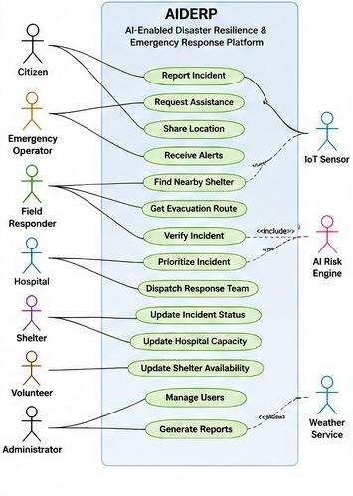

7.1 Include / Extend Relationships
- Submit Incident Report «include» Sign In.
- Raise SOS Request «include» Submit Incident Report.
- Validate Report «include» Review Evidence.
- Compute Threat Assessment «extend» Validate Report, triggered once a report is validated or reaches a trusted-source confidence threshold.
- Assign Response Team «include» Compute Threat Assessment.
- Broadcast Alert «include» Validate Report.
- Recommend Safe Route «include» Query Hazard Zones.
- Locate Relief Center «include» Query Center Capacity.
- Stream Sensor Reading «extend» Create Preliminary Report, triggered when a threshold rule fires.

8. Use Case Diagram
PlantUML specification — import into any PlantUML-compatible tool to render the graphical diagram.
@startuml
left to right direction
actor Citizen
actor "Emergency Coordinator" as Coordinator
actor "Rescue Member" as Rescue
actor "Facility Staff" as Facility
actor Admin
actor "Sensor Network" as Sensor
actor "Weather Provider" as Weather
actor "Mapping Provider" as Mapping
actor "Messaging Gateway" as Messaging
rectangle AIDERP {
usecase "Sign In" as UC1
usecase "Submit Incident Report" as UC2
usecase "Raise SOS Request" as UC3
usecase "Stream Sensor Reading" as UC4
usecase "Validate Report" as UC5
usecase "Compute Threat Assessment" as UC6
usecase "Assign Response Team" as UC7
usecase "Update Task Status" as UC8
usecase "Broadcast Alert" as UC9
usecase "Recommend Safe Route" as UC10
usecase "Locate Relief Center" as UC11
usecase "Update Center Capacity" as UC12
usecase "Manage Resources" as UC13
usecase "Administer Accounts" as UC14
}
Citizen --> UC1
Citizen --> UC2
Citizen --> UC3
Citizen --> UC9
Citizen --> UC10
Citizen --> UC11
Coordinator --> UC1
Coordinator --> UC5
Coordinator --> UC6
Coordinator --> UC7
Coordinator --> UC9
Coordinator --> UC13
Rescue --> UC8
Facility --> UC12
Admin --> UC14
Sensor --> UC4
Weather --> UC6
Mapping --> UC10
Messaging --> UC9
UC3 ..> UC2 : <<include>>
UC7 ..> UC6 : <<include>>
UC9 ..> UC5 : <<include>>
UC4 ..> UC2 : <<extend>>
@enduml

9. Object and Class Identification (CO3)
Candidate classes were derived from domain nouns (person, report, location, evidence, sensor, reading, assessment, team, equipment, assignment, alert, center, route, message, log) and their supporting verbs (submit, validate, score, assign, accept, update, broadcast, allocate, log).
Class | Key Attributes | Key Operations
Person (abstract) | personId, fullName, contact, accountStatus | authenticate(), permittedActions()
Citizen | homeZone, emergencyContact | submitReport(), raiseSOS()
Coordinator | badgeCode, shift | validateReport(), assignTeam(), broadcastAlert()
RescueMember | skillTag, availability | acceptAssignment(), updateStatus(), addObservation()
IncidentReport | reportId, category, status, validationStatus, createdAt | validate(), discard(), escalate(), close()
GeoLocation | latitude, longitude, zoneCode | distanceTo(), withinZone()
ProofAttachment | attachmentId, mediaType, uploadedAt | checkIntegrity()
SensorDevice | deviceId, deviceType, healthStatus | reportHealth()
SensorReading | readingId, metric, value, capturedAt | validate(), normalize()
ThreatAssessment | score, level, factors, recommendedAction | recompute(), explain()
ResponseTeam | teamId, specialty, availability | acceptTask(), releaseTeam()
Equipment | equipmentId, category, quantity, status | reserve(), allocate(), release()
TaskAssignment | assignmentId, priority, status, createdAt | accept(), advance(), complete(), cancel()
Broadcast | broadcastId, severity, message, targetZone | compose(), publish(), retract()
ReliefCenter (abstract) | centerId, name, location | updateCapacity()
MedicalCenter | bedsAvailable, criticalCareSlots | admitCase()
SafeShelter | capacity, occupied, accessibilityFeatures | reserveSpace()
SafeRoute | routeId, distance, hazardScore, eta | recalculate()
MessageDispatch | messageId, channel, deliveryStatus | send(), retry()
ActivityLog | entryId, actorId, action, timestamp | record(), search()

10. Class Diagram
The class model separates identity and domain entities from application services and external-provider interfaces, so that a change to a vendor API touches only an adapter, never a domain class.

@startuml
skinparam classAttributeIconSize 0
abstract class Person {
+personId: UUID
+fullName: String
+contact: String
+accountStatus: AccountStatus
+authenticate()
+permittedActions()
}
class Citizen {
+homeZone: String
+submitReport()
+raiseSOS()
}
class Coordinator {
+badgeCode: String
+validateReport()
+assignTeam()
+broadcastAlert()
}
class RescueMember {
+skillTag: String
+availability: Availability
+acceptAssignment()
+updateStatus()
}
class IncidentReport {
+reportId: UUID
+category: ReportCategory
+status: ReportStatus
+validationStatus: ValidationStatus
+validate()
+discard()
+escalate()
+close()
}
class GeoLocation {
+latitude: double
+longitude: double
+zoneCode: String
}
class ProofAttachment {
+attachmentId: UUID
+mediaType: String
+checkIntegrity()
}
class ThreatAssessment {
+score: double
+level: ThreatLevel
+recommendedAction: String
+recompute()
+explain()
}
class ResponseTeam {
+teamId: UUID
+specialty: String
+availability: Availability
}
class Equipment {
+equipmentId: UUID
+category: String
+quantity: int
+status: EquipmentStatus
+reserve()
+allocate()
+release()
}
class TaskAssignment {
+assignmentId: UUID
+status: AssignmentStatus
+priority: int
+accept()
+advance()
+complete()
}
class Broadcast {
+broadcastId: UUID
+severity: int
+message: String
+publish()
+retract()
}
abstract class ReliefCenter {
+centerId: UUID
+name: String
+updateCapacity()
}
class MedicalCenter {
+bedsAvailable: int
+criticalCareSlots: int
}
class SafeShelter {
+capacity: int
+occupied: int
}
interface ScoringStrategy {
+score(r: IncidentReport): ThreatAssessment
}
interface MappingProvider {
+route(from, to): SafeRoute
}
interface WeatherProvider {
+forecast(zone): WeatherData
}
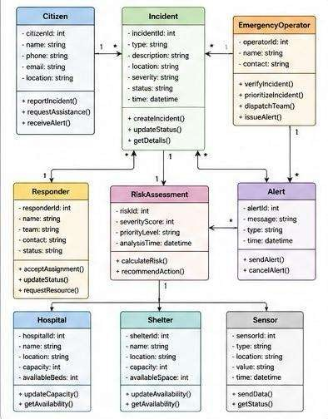

11. Sequence / Interaction Diagrams

11.1 Scenario A — Citizen reports a fire and requests help
@startuml
actor Citizen
participant "Mobile App" as App
participant "Report API" as API
participant "Report Service" as RS
participant "Threat Analysis Service" as TAS
participant "Notification Service" as NS
database "Report Store" as DB
Citizen -> App: Submit fire report + location
App -> API: POST /reports
API -> RS: createReport(data)
RS -> DB: save(status=UNVALIDATED)
RS -> TAS: preliminaryScore(report)
TAS --> RS: ThreatAssessment(draft)
RS -> DB: attach draft assessment
RS -> NS: notifyCoordinator(report)
NS --> Citizen: acknowledgement
RS --> API: report + status
API --> App: confirmation
@enduml

11.2 Scenario B — Coordinator validates and dispatches
@startuml
actor Coordinator
participant "Coordinator Console" as UI
participant "Report Service" as RS
participant "Threat Analysis Service" as TAS
participant "Dispatch Service" as DS
participant "Equipment Service" as EQ
participant "Notification Service" as NS
Coordinator -> UI: Open report
UI -> RS: getReport(id)
RS --> UI: report + evidence
Coordinator -> UI: Validate report
UI -> RS: validate(id)
RS -> TAS: assess(id)
TAS --> RS: final ThreatAssessment
Coordinator -> UI: Approve dispatch
UI -> DS: dispatch(id)
DS -> EQ: reserve(equipmentList)
EQ --> DS: reservation confirmed
DS -> NS: notifyTeam(assignment)
NS --> Coordinator: dispatch confirmed
@enduml

11.3 Scenario C — Rescue member progresses an assignment
@startuml
actor "Rescue Member" as Rescue
participant "Field App" as App
participant "Assignment Service" as AS
participant "Report Service" as RS
participant "Notification Service" as NS
Rescue -> App: Accept assignment
App -> AS: accept(assignmentId)
AS -> RS: updateStatus(EnRoute)
Rescue -> App: Arrive on site
App -> AS: updateStatus(OnSite)
Rescue -> App: Submit field observation
App -> RS: addObservation()
Rescue -> App: Mark resolved
App -> AS: complete()
AS -> RS: updateStatus(Resolved)
AS -> NS: notifyCoordinatorAndCitizen()
@enduml
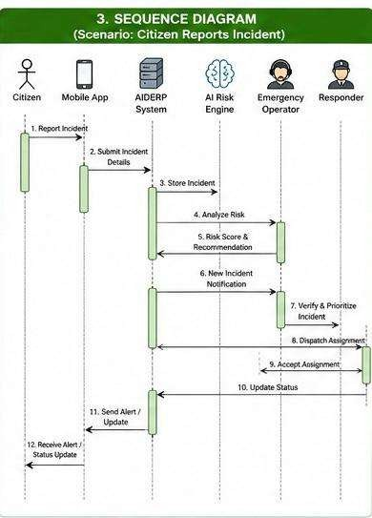

12. Activity Diagram
@startuml
start
:Receive incident report;
:Check required fields;
if (Complete?) then (yes)
:Store as Unvalidated;
:Correlate with sensor / weather data;
:Run preliminary threat scoring;
if (Immediate danger indicated?) then (yes)
:Fast-track to coordinator queue;
else (no)
:Place in standard review queue;
endif
:Coordinator reviews evidence;
if (Validated?) then (yes)
:Finalise threat assessment;
:Select team and equipment;
:Create task assignment;
:Broadcast alert if required;
:Monitor field status;
if (Resolved?) then (yes)
:Close report;
:Write audit entry;
else (no)
:Request additional resources;
endif
else (no)
:Mark discarded;
:Write audit entry;
endif
else (no)
:Return validation error;
endif
stop
@enduml

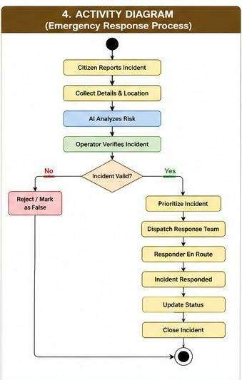

13. State Transition Diagram
@startuml
[*] --> Submitted
Submitted --> PendingReview : queued
Submitted --> FastTracked : threshold rule fires
FastTracked --> PendingReview
PendingReview --> Validated : evidence sufficient
PendingReview --> Discarded : invalid / duplicate
Validated --> Scored : threat assessed
Scored --> TeamAssigned : resources reserved
TeamAssigned --> EnRoute : team accepts
EnRoute --> OnSite : arrival confirmed
OnSite --> InProgress : response begins
InProgress --> ResourceShortfall : shortage detected
ResourceShortfall --> InProgress : resources replenished
InProgress --> Contained : hazard controlled
Contained --> Closed : coordinator confirms
Discarded --> [*]
Closed --> [*]
@enduml

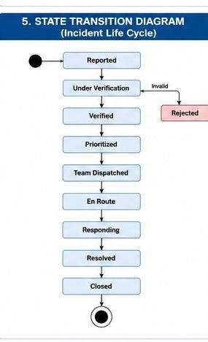

14. Package Diagram
@startuml
package "Presentation" {
[Citizen App]
[Coordinator Console]
[Field App]
}
package "Application Services" {
[Report Service]
[Dispatch Service]
[Broadcast Service]
[Route Service]
[Center Service]
[Equipment Service]
}
package "Domain Model" {
[IncidentReport]
[TaskAssignment]
[ThreatAssessment]
[Equipment]
[ReliefCenter]
[Person]
}
package "Infrastructure" {
[Repositories]
[Event Bus]
[Cache]
[Audit Store]
}
package "External Adapters" {
[Mapping Adapter]
[Weather Adapter]
[Messaging Adapter]
[Sensor Adapter]
}
[Citizen App] --> [Report Service]
[Coordinator Console] --> [Report Service]
[Coordinator Console] --> [Dispatch Service]
[Field App] --> [Dispatch Service]
[Report Service] --> [IncidentReport]
[Dispatch Service] --> [TaskAssignment]
[Dispatch Service] --> [Equipment]
[Broadcast Service] --> [Event Bus]
[Report Service] --> [Repositories]
[Application Services] --> [External Adapters]
[Application Services] --> [Domain Model]
@enduml
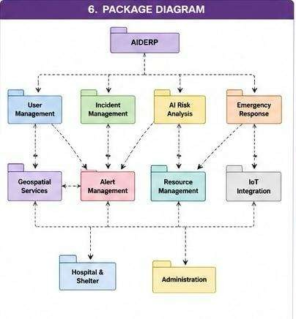

15. Component Diagram
@startuml
component "API Gateway" as API
component "Identity & Access" as IAM
component "Report Service" as RS
component "Threat Analysis Service" as TAS
component "Dispatch & Equipment Service" as DS
component "Broadcast Service" as BS
component "Route Service" as RTS
component "Center Service" as CS
component "Sensor Ingestion Service" as SIS
component "Audit Service" as AUD
database "Operational DB" as DB
queue "Event Bus" as BUS
cloud "Weather API" as W
cloud "Mapping API" as M
cloud "Messaging Gateway" as MG
node "Sensor Gateway" as SG
API --> IAM
API --> RS
API --> DS
API --> CS
RS --> TAS
RS --> AUD
DS --> TAS
DS --> AUD
BS --> BUS
RS --> BUS
SIS --> BUS
SIS --> DB
RS --> DB
DS --> DB
CS --> DB
AUD --> DB
TAS --> W
RTS --> M
BS --> MG
SG --> SIS
@enduml
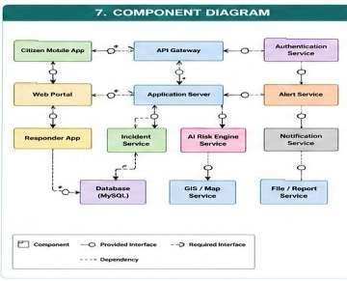

16. Deployment Diagram
@startuml
node "Citizen Device" as C
node "Rescue Member Device" as R
node "Coordinator Workstation" as O
node "Sensor Edge Gateway" as E
node "Cloud Region" {
node "Load Balancer" as LB
node "Container Cluster" {
node "API Gateway Pod" as AP
node "Report Service Pods" as RP
node "Dispatch Service Pods" as DP
node "Threat Service Pods" as TP
node "Broadcast Pods" as BP
node "Sensor Ingestion Pods" as SP
}
database "Primary Database" as DB
database "Read Replica" as RB
queue "Message Broker" as MQ
}
cloud "Weather Provider" as W
cloud "Mapping Provider" as G
cloud "Messaging Gateway" as N
C --> LB
R --> LB
O --> LB
E --> SP
LB --> AP
AP --> RP
AP --> DP
RP --> TP
DP --> TP
RP --> MQ
SP --> MQ
BP --> MQ
RP --> DB
DP --> DB
SP --> DB
DB --> RB
TP --> W
TP --> G
BP --> N
@enduml

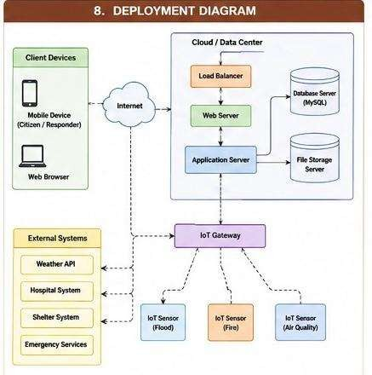

17. Object Responsibility Analysis
Responsibilities are assigned using GRASP: Information Expert, Creator, Controller, Low Coupling, High Cohesion and Protected Variation.

Class / Service | Responsibility | GRASP Rationale
IncidentReport | Own report state and enforce legal lifecycle transitions | Information Expert — the report knows its own status rules
ThreatAssessment | Represent a score, level and recommendation | Separated from the service that computes it
ThreatAnalysisService | Coordinate inputs and invoke the configured ScoringStrategy | Controller
DispatchService | Coordinate team selection and equipment reservation | Controller; protects the dispatch workflow from direct manipulation
Equipment | Maintain its own quantity and reservation invariants | Information Expert
BroadcastService | Compose, target and publish alerts | High Cohesion — notification policy stays out of IncidentReport
RouteService | Request and validate a route through MappingProvider | Protected Variation via interface
ReliefCenter | Maintain capacity and availability | Information Expert
ActivityLog / AuditService | Record security-relevant and operational actions | Cross-cutting concern isolated from domain classes
Person / role subtypes | Represent identity and permitted actions | Security boundary, Low Coupling with business services
Anti-patterns deliberately avoided: IncidentReport never calls a mapping, messaging or weather API directly; the presentation layer never writes to the database; and ScoringStrategy never triggers a dispatch on its own — DispatchService always mediates that step through an authorised Coordinator action.

18. Design Axioms, Principles and Patterns

18.1 Design Axioms
- Independence — a change to an external provider should require no change to a domain class.
- Minimum coupling — services communicate through interfaces and events, not shared mutable state.
- Maximum cohesion — each class or service has one focused reason to change.
- Information hiding — internal state changes only through guarded operations.
- Traceability — every functional requirement maps to a use case and supporting classes (Section 20).

18.2 SOLID and Related Principles
Principle | Application in AIDERP
Single Responsibility | Report lifecycle, threat scoring, dispatch and notification live in separate services
Open/Closed | New disaster or sensor categories are added through configuration/strategy, not by editing core workflow code
Liskov Substitution | MedicalCenter and SafeShelter can be used wherever ReliefCenter is expected
Interface Segregation | MappingProvider, WeatherProvider and MessagingProvider each expose a narrow, focused contract
Dependency Inversion | Application services depend on provider interfaces, never on a specific vendor SDK

18.3 Design Patterns
Pattern | Problem Addressed | Justification
Strategy | Multiple scoring approaches | ScoringStrategy lets the algorithm vary by disaster type without touching ThreatAnalysisService
Adapter | Volatile external APIs | Mapping, weather, messaging and sensor providers are normalised behind stable interfaces
Observer / Publish-Subscribe | Broadcast and event distribution | Event Bus lets multiple subscribers react to a report or sensor event without direct coupling
State | Report and assignment lifecycle | Makes legal transitions explicit and rejects invalid status changes
Chain of Responsibility | Escalation of unresolved or ageing reports | A report can be passed up a chain of increasingly senior coordinators until one handles it
Factory Method | Creating channel-specific notifications | A common creation step returns an SMS, push or email MessageDispatch implementation
Repository | Persistence isolation | Domain services depend on a repository contract, not a specific database driver
Facade | Simplified operator workflow | A single Emergency Operations façade hides the coordination across several services
Circuit Breaker | Protecting the system from a failing external provider | Stops repeated calls to an unhealthy mapping/weather/messaging endpoint

19. Assumptions, Constraints, Security and Privacy

19.1 Assumptions
- Citizens and field staff have access to a supported device or an assisted-reporting channel.
- Sensor readings include device identity, timestamp and location metadata.
- Coordinators hold defined authority to validate reports and approve dispatch.
- External providers may be temporarily unavailable and must degrade gracefully rather than block core intake.
- Scoring models are periodically reviewed for drift and are not treated as final authority.

19.2 Constraints
- All UML views must remain mutually consistent as the design evolves.
- Validated and unvalidated information must be visibly distinguishable throughout the UI and API.
- Every state-changing operation requires authentication and role-based authorization.
- The design must tolerate partial external-provider failure without losing core incident intake.

19.3 Security Architecture
Control | Application
Authentication | Short-lived session tokens; secure credential storage for local accounts
Authorization | Role-based access control plus zone/resource-level policy checks
Transport security | TLS for all internal and external API traffic
Data protection | Encryption at rest for sensitive stores; managed key rotation
Audit | Tamper-resistant logging of validation, dispatch, role changes and alert publication
Input validation | Schema checks, bounds checking and sensor-plausibility rules
Rate limiting | Protects public-facing report and SOS endpoints from abuse
Secrets management | Externalised secret storage; no credentials in source control
Resilience | Retries with backoff, circuit breakers, queues and health probes
Model governance | Score, model version and contributing factors are logged; a human retains final authority

19.4 Privacy
Location is treated as sensitive operational data: precision is reduced wherever exact coordinates are not required, access is limited by role and incident relevance, retention periods are defined, and citizen identity is withheld from actors who do not need it to act on a report.

20. Requirement-to-Use Case/Class Traceability Matrix
Requirement | Use Case | Supporting Classes
FR-2 | UC-2 | Citizen, IncidentReport, GeoLocation, ProofAttachment
FR-3 | UC-3 | Citizen, IncidentReport, TaskAssignment
FR-4 | UC-4 | SensorDevice, SensorReading, IncidentReport
FR-5 | UC-5 | Coordinator, IncidentReport
FR-6 | UC-6 | ThreatAssessment, ThreatAnalysisService, ScoringStrategy
FR-7 | UC-7 | DispatchService, TaskAssignment, Equipment, ResponseTeam
FR-8 | UC-8 | RescueMember, TaskAssignment, IncidentReport
FR-9 | UC-9 | Broadcast, BroadcastService, MessageDispatch
FR-10 | UC-10 | SafeRoute, RouteService, MappingProvider
FR-12 | UC-12 | ReliefCenter, MedicalCenter, SafeShelter
FR-14 | — | ActivityLog, AuditService

21. Implementation / Prototype and Results

21.1 Suggested Technology Stack
Layer | Suggested Technology | Purpose
Frontend | React + TypeScript | Citizen, coordinator and field interfaces
Backend | Java (Spring Boot) REST APIs | Application services and orchestration
Database | PostgreSQL | Reports, assignments, centers, audit data
Cache | Redis | Short-lived operational data and rate limiting
Message broker | Apache Kafka / managed queue | Sensor and notification events
Scoring service | Python (FastAPI) model-serving endpoint | Threat scoring and recommendations
Mapping | External GIS provider API | Geocoding, routing and spatial layers
Deployment | Docker + Kubernetes | Repeatable, scalable deployment

21.2 Representative API Design
Method | Endpoint | Purpose
POST | /api/auth/login | Authenticate user and issue session token
POST | /api/reports | Submit a citizen incident report
POST | /api/reports/{id}/validate | Validate or discard a report
POST | /api/reports/{id}/assess | Trigger threat assessment
POST | /api/reports/{id}/dispatch | Create a task assignment
PATCH | /api/assignments/{id} | Update assignment / task status
POST | /api/broadcasts | Publish a validated alert
GET | /api/routes/safe | Compute a hazard-aware safe route
GET | /api/centers/nearby | Find nearby relief centers
PATCH | /api/centers/{id}/capacity | Update capacity
POST | /api/sensors/readings | Ingest a sensor reading

21.3 Representative Domain Pseudocode
function submitReport(data):
validateSchema(data)
location = GeoLocation(data.lat, data.lng)
report = IncidentReport.create(data.category, location)
report.validationStatus = UNVALIDATED
for file in data.attachments:
report.addAttachment(ProofAttachment.from(file))
reportRepository.save(report)
draft = threatAnalysisService.preliminaryScore(report)
report.attachAssessment(draft)
eventBus.publish(ReportCreated(report.id))
return report
function validateReport(coordinator, reportId, decision):
authorize(coordinator, "VALIDATE_REPORT")
report = reportRepository.find(reportId)
assert report.status not in [CLOSED, DISCARDED]
if decision == VALIDATED:
report.validate()
threatAnalysisService.assess(report)
else:
report.discard()
auditService.record(coordinator, reportId, decision)
reportRepository.save(report)

21.4 Expected Test Outcomes
Test Area | Expected Result
Citizen report | Report stored with UNVALIDATED status and acknowledgement returned
Invalid report | Validation error returned; no partial record persisted
Threat scoring | Score and recommendation stored with model version metadata
Coordinator validation | Only an authorized coordinator can change validation status
Dispatch | Assignment created only when equipment can be reserved
Field update | Legal state transitions accepted; illegal transitions rejected
Broadcast | Only validated, authorized alerts are published
Provider outage | Core report handling remains available; route/weather features degrade gracefully
Audit | Every privileged action produces a traceable log entry

22. Consistency and Design Evaluation

22.1 Cross-Model Consistency Checks
- Every use case in Section 7 is backed by at least one class or service in Section 9.
- Sequence-diagram messages correspond to operations declared on the relevant classes.
- States in Section 13 match the status values used by IncidentReport and TaskAssignment.
- Component boundaries in Section 15 match the package responsibilities in Section 14.
- Deployment nodes in Section 16 host exactly the components identified in Section 15.

22.2 Quality Evaluation
Quality | Evaluation
Modularity | High — services split along business capability, not technical layer alone
Maintainability | High — interfaces and patterns isolate external volatility
Scalability | High — stateless services and event-driven ingestion support horizontal scaling
Resilience | High at the architectural level — queues, retries and circuit breakers specified
Security | Role-based authorization, audit trail and encrypted transport included
Explainability | Threat score and recommendation are stored separately from the final human decision

22.3 Residual Design Risks
- Sensor false positives may generate unnecessary preliminary reports — mitigated by correlation and coordinator review.
- Model false negatives could under-prioritise a genuine emergency — mitigated by rule-based safety floors alongside the learned score.
- Network loss can isolate field devices — mitigated by offline queuing and later synchronisation.
- Stale capacity data could mislead citizens — mitigated by displaying a last-updated timestamp on every center listing.

23. SDG Relevance and Course Outcome Mapping
SDG | Contribution of AIDERP
SDG 3 — Good Health and Well-being | Faster assistance requests, medical-capacity visibility and evacuation guidance reduce harm during emergencies
SDG 9 — Industry, Innovation and Infrastructure | IoT integration and a resilient service architecture support a modern emergency-response infrastructure
SDG 11 — Sustainable Cities and Communities | Shelter guidance, hazard-aware routing and coordinated response strengthen community resilience
SDG 13 — Climate Action | Flood, heat and structural sensor integration improves preparedness for climate-related hazards

23.1 Course Outcome Achievement
- CO1 — object-oriented fundamentals, the OO development life cycle, hybrid Agile practice and Model-Driven Development are applied in Section 3.
- CO2 — Use Case, Class, Sequence, Activity, State, Package, Component and Deployment views are produced in Sections 8–16.
- CO3 — objects, classes, attributes, methods, relationships and responsibilities are identified and justified in Sections 9 and 17–18.

24. Reflection on Design Decisions
The hardest modelling decision in this assignment was where to place the boundary between an automated recommendation and a human decision. It would have been simpler to let a high threat score trigger dispatch directly, but that removes the accountability that emergency response actually requires. Keeping ThreatAssessment as a separate, explainable object rather than a hidden field inside IncidentReport made it possible to show the recommendation to a coordinator without letting it silently become the decision.
A second lesson was how tightly the eight UML views depend on each other in practice. Changing a single state name in the State Transition Diagram required a matching change in the Class Diagram's status attribute, in the Sequence Diagram messages that set it, and in the Activity Diagram branch that tests it. Treating the diagrams as one connected model, rather than eight separate drawings, was necessary to keep the design internally consistent.
Applying Strategy, Adapter, State, Chain of Responsibility, Factory Method, Repository, Facade and Circuit Breaker showed how each pattern solves a specific, named volatility in the domain — vendor change, escalation policy, notification channel, persistence technology or provider outage — rather than being included for their own sake. Interface-based integration also made the design easier to test, since external mapping, weather and messaging services can be replaced by test doubles without touching domain logic.

25. Conclusion
This report has developed an Object-Oriented Analysis and Design model for AIDERP that identifies the system's actors, domain objects, classes, responsibilities, relationships and external interfaces, and expresses them through eight complementary UML views. The design keeps unverified and verified information explicitly distinct, applies encapsulation, abstraction, inheritance and polymorphism where they add real value, and follows high-cohesion, low-coupling principles throughout.
Automated threat scoring is positioned as decision support rather than an unquestionable command, and authority to validate, dispatch and broadcast remains with an authenticated human coordinator. The resulting architecture is scalable and resilient through service separation, event-driven communication, provider adapters, caching, queuing, audit logging and graceful degradation, and the traceability matrix in Section 20 connects every functional requirement back to a concrete use case and set of supporting classes.

26. GitHub Repository Plan

Folder / File | Content
README.md | Project overview, objectives, architecture summary, setup instructions
docs/requirements | Functional/non-functional requirements and traceability matrix
docs/uml | PlantUML source files and exported diagram images
src/frontend | Citizen, coordinator and field UI prototype
src/backend | REST APIs, domain classes, application services and adapters
src/scoring | Threat-scoring prototype service
database | Schema, migrations and seed data
tests | Unit, integration and API test suites
REPORT.docx | This assignment report

Repository link:

27. References
1. Object Management Group (OMG), Unified Modeling Language (UML) Specification.
2. Object Management Group (OMG), Model Driven Architecture (MDA) Guide.
3. Craig Larman, Applying UML and Patterns: An Introduction to Object-Oriented Analysis and Design and Iterative Development.
4. Ivar Jacobson, Grady Booch and James Rumbaugh, The Unified Software Development Process.
5. Erich Gamma, Richard Helm, Ralph Johnson and John Vlissides, Design Patterns: Elements of Reusable Object-Oriented Software.
6. Robert C. Martin, Agile Principles, Patterns and Practices.
7. ISO/IEC 25010, Systems and Software Quality Requirements and Evaluation (SQuaRE).
8. OWASP Foundation, Application Security Verification Standard.
9. United Nations, Sustainable Development Goals — SDG 3, SDG 9, SDG 11 and SDG 13.

